“我有…谁有…I HAVE…WHO HAS”

Time keeping sheet
Please record the time that your group completes the “我有…谁有…”game. You should use Chinese board game sentences to communicate with your group members.

Record the time your team completes the game and see if you can improve the speed. Please write time in CHARACTERS.

次= times 第一= first 第二= second 第三= 第四= 第五=

 | 分 （minute） | 秒 （second）
第一次
第二次
第三次
第四次

“我有…谁有…I HAVE…WHO HAS”

Time keeping sheet

Please record the time that your group completes the “我有…谁有…”game. You should use Chinese board game sentences to communicate with your group members.

Record the time your team completes the game and see if you can improve the speed. Please write time in CHARACTERS.

次= times 第一= first 第二= second 第三= 第四= 第五=

 | 分 （minute） | 秒 （second）
第一次
第二次
第三次
第四次

我有 “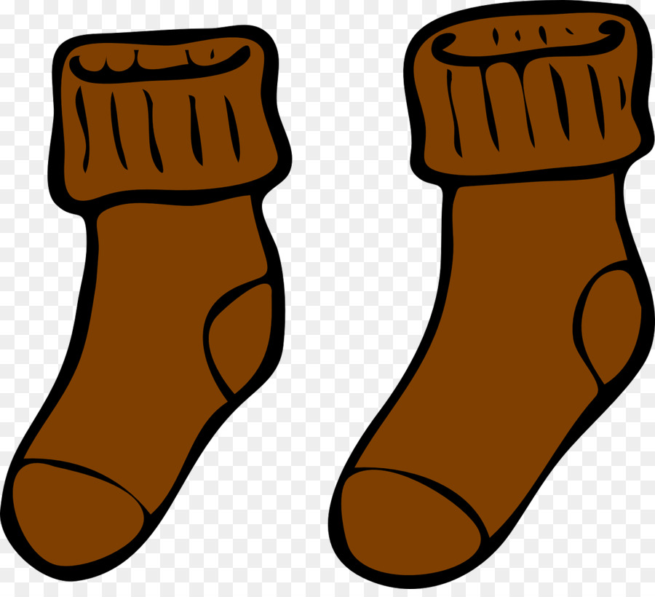的袜子”

谁有 “粉色的裙子”？

我有“的裙子”

谁有“橙色的雨伞”?

我有“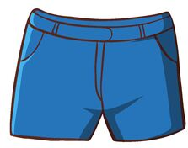的短裤”

谁有“绿色的雨衣”？
我有“的雨衣”

谁有 “棕的袜子”？
我有“的鞋子”

谁有“黄色的上衣”？
我有“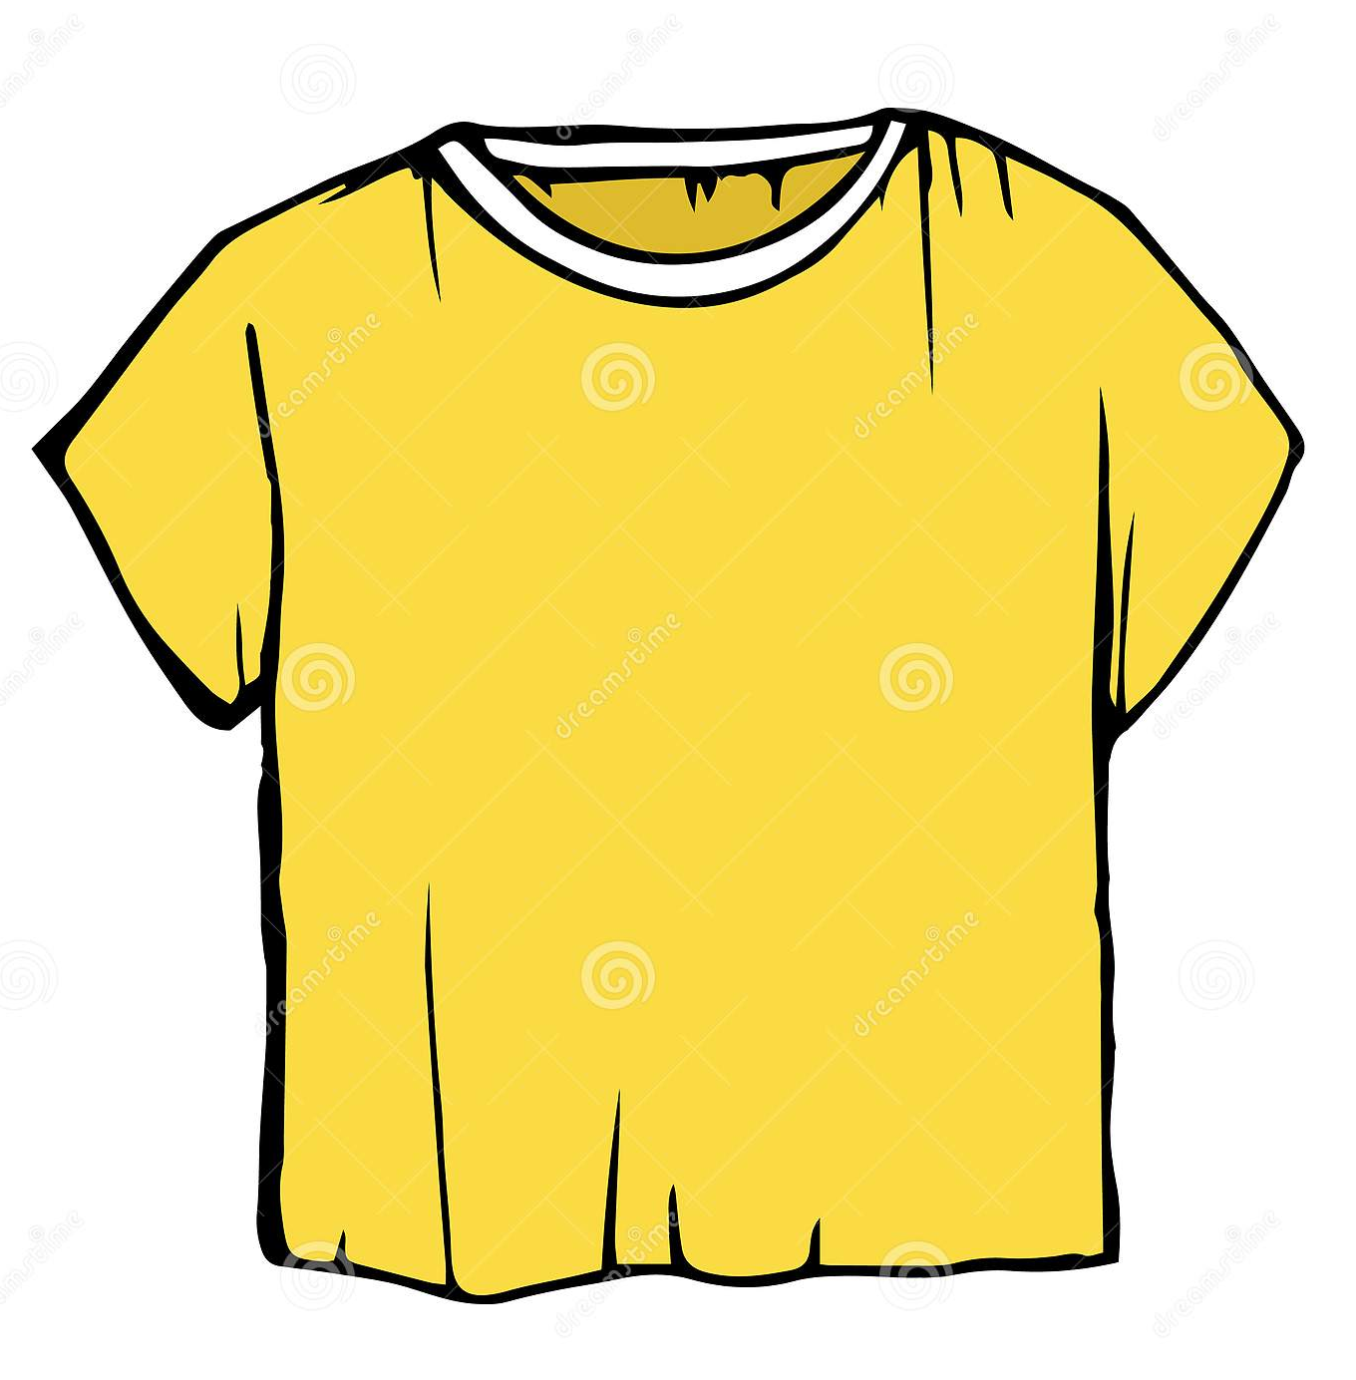的上衣”

谁有“蓝色的短裤”？
我有“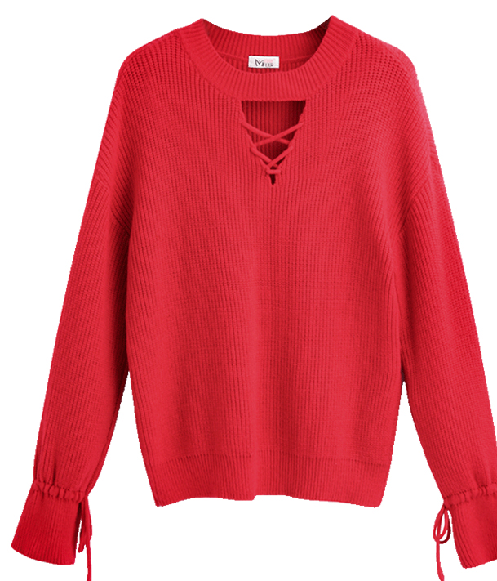 的毛衣”
谁有“黑色的外套”？
我有“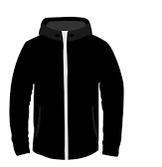的外套”

谁有“白色的鞋子”？

我有“的雨伞”
谁有“紫色的背心”？
我有“的背心”

谁有“红色的毛衣”？

